Progressive Farmer: Shri. N. Mohammed, Calicut

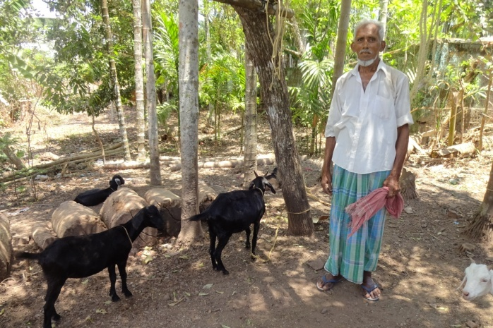
Shri N.Mohammed 75 yrs old, a resident of Calicut village, South Andaman started goat farming three years ago with a pair of adult does purchased with initial investment of Rs. I800. He managed goats under semi range system in a kachha goat shelter. He used to feed his goats with locally available tree leaves, open day grazing and supplementation of little quantity of wheat and rice starch. He recycled the born kids for the expansion of his goat stock. He came to contact with the Scientists of ICAR-CIARI during awareness programme. With the technical support of CIARI now he managed to strengthen his stock to 20 goats and also constructed a wooden goat shelter. He also started feeding his goats with mineral mixtures and vitamins tonic provided by the CIARI and is happy about the health, growth and performance of his goat stock. Till date he has sold 5 adult bucks and 2 adult does and earned Rs. 47000. With his earning he is now able to support his family with wishes to increase the number of stock for better income and livelihood security. ICAR-CIARI is constantly giving technical support for improvement of reproductive performance and health management to enhance his goat population with higher market body weight.

